CHAPTER 11: DIALOG BOXES - A DEEP DIVE

Introduction:

Dialog boxes play a crucial role in user interaction, allowing programs to gather additional input beyond simple menus. They typically appear as popup windows containing various child window controls like text boxes, buttons, and radio buttons.

Dialog Box Creation:

Templates: Developers define the layout and appearance of dialog boxes through templates embedded within the program's resource script file. These templates specify the size, position, and type of each control within the dialog box.

Visual Studio: Modern development environments like Visual Studio offer interactive tools for designing dialog boxes. This simplifies the process and generates the corresponding resource script code automatically.

Dialog Box Management:

Windows Responsibility: Upon invocation, Windows 98 takes over the responsibility of creating the dialog box window, its child controls, and a dedicated window procedure to handle messages.

Dialog Box Manager: This internal Windows code manages various aspects of the dialog box, including keyboard and mouse input, and provides the framework for interaction.

Dialog Procedure:

Program-Defined Function: While Windows handles core functionality, developers can implement a custom "dialog box procedure" to perform specific tasks.

Purpose: This procedure typically initializes child controls, processes messages from them (e.g., button clicks), and handles the dialog box's closing.

Focus and Input: Unlike standalone windows, dialog box procedures don't handle WM_PAINT messages directly or directly process keyboard/mouse input.

Child Window Controls in Dialog Boxes:

Simplified Management: Compared to managing child windows in standalone programs, dialog boxes offer a simpler approach.

Windows Assistance: The built-in dialog box manager takes care of many tasks, including handling focus transition between controls, which was a challenge in Chapter 9.

Building a Simple Dialog Box:

This chapter explores the process of creating and implementing a simple dialog box, showcasing the interplay between the various components involved.

Additional Considerations:

Complexity: While the focus is on a basic example, creating complex dialog boxes with rich features requires more advanced techniques covered later.

Learning Curve: While leveraging child controls within dialog boxes simplifies certain aspects, it introduces new concepts and procedures specific to dialog box interaction.

MODELESS DIALOG BOXES: BEYOND MODALITY

This section delves deeper into the concept of modeless dialog boxes, exploring their characteristics and contrasting them with modal dialog boxes.

Recap: Modal vs. Modeless Dialog Boxes:

Modal: These dialog boxes restrict user interaction to only the dialog box and the program that initiated it. They block access to other windows within the program until closed.

Modeless: These dialog boxes offer greater flexibility by allowing users to switch between the dialog box, the program, and even other applications concurrently.

Benefits of Modeless Dialog Boxes:

Enhanced User Experience: Users can keep the dialog box open for reference while working within the main program, avoiding the need to repeatedly open and close it.

Improved Efficiency: Tasks requiring frequent interaction with both the dialog box and the program are streamlined, minimizing context switching and saving time.

Greater Flexibility: Users can access information displayed in the dialog box while working on other tasks, promoting multitasking and efficient workflow.

Function Comparison: DialogBox vs. CreateDialog

DialogBox: This function is specifically designed for modal dialog boxes. It creates the dialog box, handles user interaction, and only returns after the dialog box is closed.

CreateDialog: This function creates modeless dialog boxes. It returns immediately after creation, handing over the responsibility of managing the dialog box to the program.

Code Comparison:

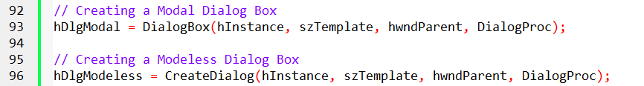

Remembering the Difference:

The function names provide a clue to their purpose. "DialogBox" emphasizes the box-like nature of modal dialogs, while "CreateDialog" aligns with the creation of regular windows, similar to "CreateWindow".

Additional Considerations:

Modeless dialog boxes require more careful management than modal ones. Developers need to handle closing, responding to user actions, and ensuring the dialog box remains accessible while not interfering with the main window.

The choice between modal and modeless depends on the specific needs of the application and the intended user interaction.

Deep Dive: Modeless Dialog Boxes and Their Differences

This section delves deeper into the differences between modal and modeless dialog boxes, highlighting key aspects and implementation considerations.

Visual Differences:

Caption Bar and System Menu: Unlike modal dialogs, modeless ones typically include a caption bar for moving the window and a system menu for additional options. This is reflected in the dialog template's STYLE statement, which usually includes WS_CAPTION and WS_SYSMENU styles.

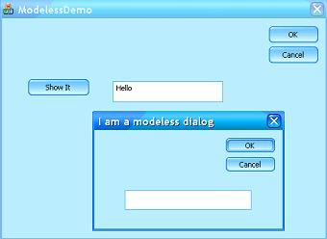

Visibility: Defaulting to hidden, modeless dialog boxes require either the WS_VISIBLE style in the template or an explicit ShowWindow call with SW_SHOW to become visible. This differs from modal dialogs which are displayed automatically.



Message Handling:

Message Queue: Messages intended for modeless dialog boxes are delivered through the program's message queue, requiring special handling.

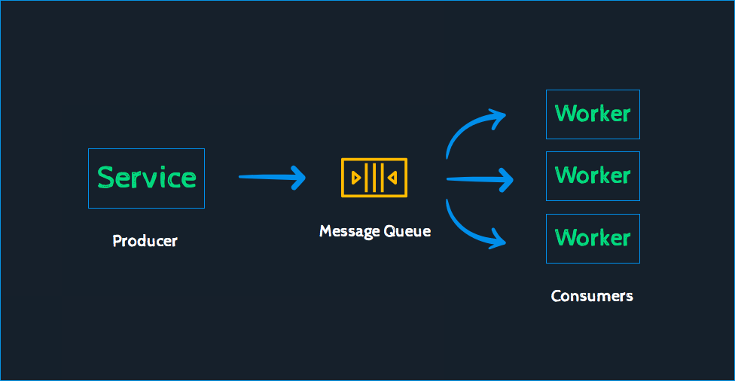

IsDialogMessage: This function determines if a message is intended for the modeless dialog box. If so, it sends the message to the appropriate window procedure and returns TRUE. Otherwise, it returns FALSE.

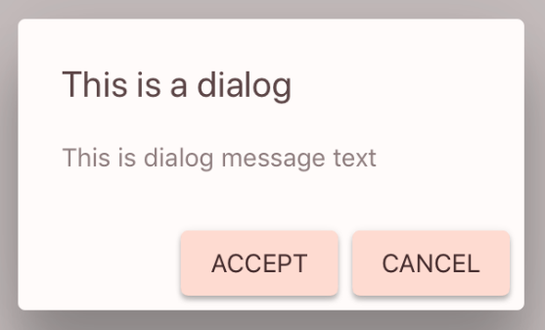

Modified Message Loop: The program's main message loop needs to incorporate IsDialogMessage to filter and dispatch messages accordingly. The basic structure involves checking the dialog box handle (hDlgModeless) and using IsDialogMessage before calling TranslateMessage and DispatchMessage.

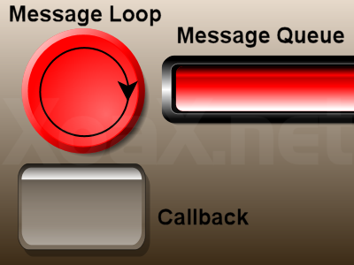

Keyboard Accelerators: Programs using keyboard accelerators need to further refine their message loop to ensure proper handling of accelerator messages alongside dialog box messages.

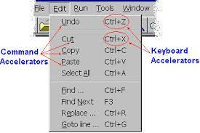

Code Comparison:

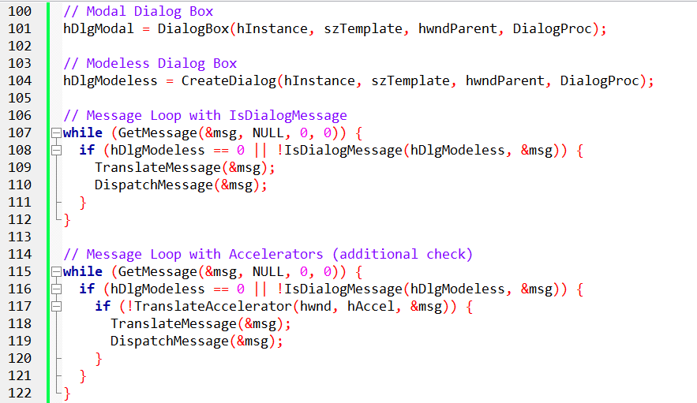

Additional Considerations:

Managing focus: Modeless dialog boxes need careful attention to focus management, ensuring proper focus transitions between the dialog box and other windows.

Memory management: Since the dialog box remains open, proper memory management of the associated window handle is crucial.

User experience: Modeless dialog boxes offer greater flexibility but require careful design to avoid cluttering the desktop and interfering with the main program's functionality.

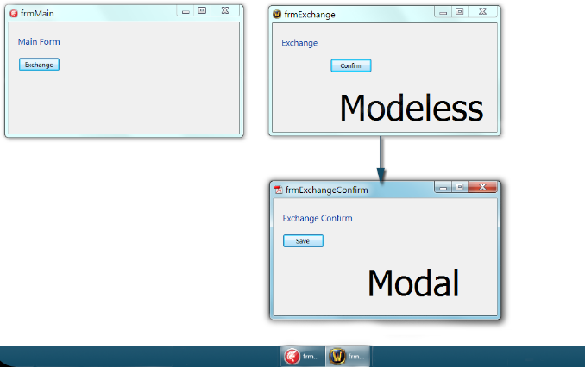

In this example:

Modal Dialog Box:

* The dialog box has no caption bar or system menu.
* The dialog box is fully opaque and blocks the underlying window.
* The dialog box must be closed before the user can interact with the underlying window.

Modeless Dialog Box:

* The dialog box has a caption bar and system menu.
* The dialog box is semi-transparent, allowing the underlying window to be partially visible.
* The user can interact with the underlying window while the dialog box is open.

In the image, the "Exchange" dialog box is a modal dialog box, while the "Confirm" dialog box is a modeless dialog box.

Here is a table that summarizes the key differences between modal and modeless dialog boxes:

